**FORMAN CHRISTIAN COLLEGE**

**(A CHARTERED UNIVERSITY)**



**Embedded Systems (CSCS 306)**

**FALL-2019**

**LAB-04**

**Chemical Factory Dryer Simulation**

**Group Members:**

* Mohammad Usman 20-10558
* Haris Naseer 20-10612
* Abeer Butt 20-10596

**Introduction:**

The aim of the lab was to test our skills in dealing with an LCD & LM35DZ interfacing with Arduino. It tested our coding skills, basically our logic in dealing with user input through buttons, processing it and displaying meaningful information on the LCD. This lab consists of only one LabTask.

**LabTask:** In this LabTask, we had to use the LiquidCrystal library to interface with the LCD. On startup, we had to display a meaningful prompt on the LCD. Then the user would enter a number representing temperature in Celsius which should be between 20 and 80oC with the help of 2 push buttons, one for tens digit and one for units digit. After that, the user submits the temperature by pushing the submit button. If the entered temperature is greater than the temperature read by the LM35DZ, then the LED will light up, otherwise, the LED stays off.

**Working Code:**

**LabTask:**

// include the library code:

#include <LiquidCrystal.h>

// initialize the library with the numbers of the interface pins

LiquidCrystal lcd(12, 11, 5, 4, 3, 2);

const int sensor = A0; // Assigning analog pin A5 to variable 'sensor'

float tempc; // variable to store temperature in degree Celsius

float vout; // temporary variable to hold sensor reading

const int led = 10;

const int ten = 9;

const int unit = 8;

const int submit = 6;

bool isUnitButtonPressed = false;

bool isTenButtonPressed = false;

bool isSubmitButtonPressed = false;

int unitCounter = 0; // counter for unit

int tenCounter = 0; // counter for ten

int incUnitState = 0; // current state of the inc. unit button

int prevIncUnitState = 0; // previous state of the inc. unit button

int incTenState = 0; // current state of the inc. ten button

int prevIncTenState = 0; // previous state of the inc. ten button

int submitState = 0; // current state of the submit button

int prevSubmitState = 0; // previous state of the submit button

void setup()

{

Serial.begin(9600);

pinMode(unit, INPUT); // inc. unit button

pinMode(ten, INPUT); // inc. ten button

pinMode(submit, INPUT); // submit button

pinMode(led, OUTPUT); // LED

// set up the LCD's number of columns and rows:

delay(500);

lcd.begin(20, 4);

delay(500);

lcd.clear();

delay(500);

lcd.print("Enter: ");

lcd.setCursor(7, 0);

lcd.print(tenCounter);

lcd.setCursor(8, 0);

lcd.print(unitCounter);

lcd.blink();

}

void loop()

{

incUnitState = digitalRead(unit); // read

incTenState = digitalRead(ten); // read

submitState = digitalRead(submit); // read

incUnitButton(); // check unit button

incTenButton(); // check ten button

checkSubmitButton(); // check submit button

if (isSubmitButtonPressed)

{

String unitStr = String(unitCounter);

String tenStr = String(tenCounter);

tenStr.concat(unitStr);

int number = tenStr.toInt();

Serial.print("Entered Temp: ");

Serial.println(number);

if (number >= 20 && number <= 80)

{

vout = analogRead(sensor); //Reading the value from sensor

vout = (vout * 500) / 1023; // convert voltage to temp.

tempc = vout; // Storing value in Degree Celsius

lcd.setCursor(0, 1);

lcd.print(tempc);

Serial.print("Read Temp: ");

Serial.println(tempc);

if (tempc < number)

{

digitalWrite(led, HIGH);

Serial.println("LED - on");

}

else

{

digitalWrite(led, LOW);

Serial.println("LED - off");

}

}

else

{

Serial.println("Value Range Error!");

}

}

}

// checks conditions for submit button

void checkSubmitButton()

{

// compare the incState to its previous state

if (submitState != prevSubmitState)

{

// if the state has changed, increment the counter

if (submitState)

{

isSubmitButtonPressed = true;

Serial.println("Submit - on");

}

else

{

Serial.println("Submit - off");

}

// Delay a little bit to avoid bouncing

delay(50);

}

// save the current state as the prev state, for next time through the loop

prevSubmitState = submitState;

}

// checks conditions for unit button

void incUnitButton()

{

// compare to its previous state

if (incUnitState != prevIncUnitState)

{

// if the state has changed

if (incUnitState)

{

// isUnitButtonPressed = true;

unitCounter++;

if (unitCounter > 9)

unitCounter = 0;

Serial.print("Unit Increment - on - ");

Serial.println(unitCounter);

lcd.setCursor(8, 0);

lcd.print(unitCounter);

}

else

{

Serial.println("Unit Increment - off");

}

// Delay a little bit to avoid bouncing

delay(50);

}

// save the current state as the prev state, for next time through the loop

prevIncUnitState = incUnitState;

}

// checks conditions for ten button

void incTenButton()

{

// compare to its previous state

if (incTenState != prevIncTenState)

{

// if the state has changed

if (incTenState)

{

// isTenButtonPressed = true;

tenCounter++;

if (tenCounter > 9)

tenCounter = 0;

Serial.print("Ten Increment - on - ");

Serial.println(tenCounter);

lcd.setCursor(7, 0);

lcd.print(tenCounter);

}

else

{

Serial.println("Ten Increment - off");

}

// Delay a little bit to avoid bouncing

delay(50);

}

// save the current state as the prev state, for next time through the loop

prevIncTenState = incTenState;

}

**Circuit Diagram:**

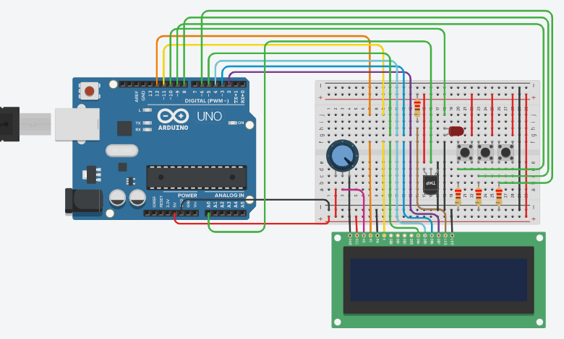

**Running Project Image:**

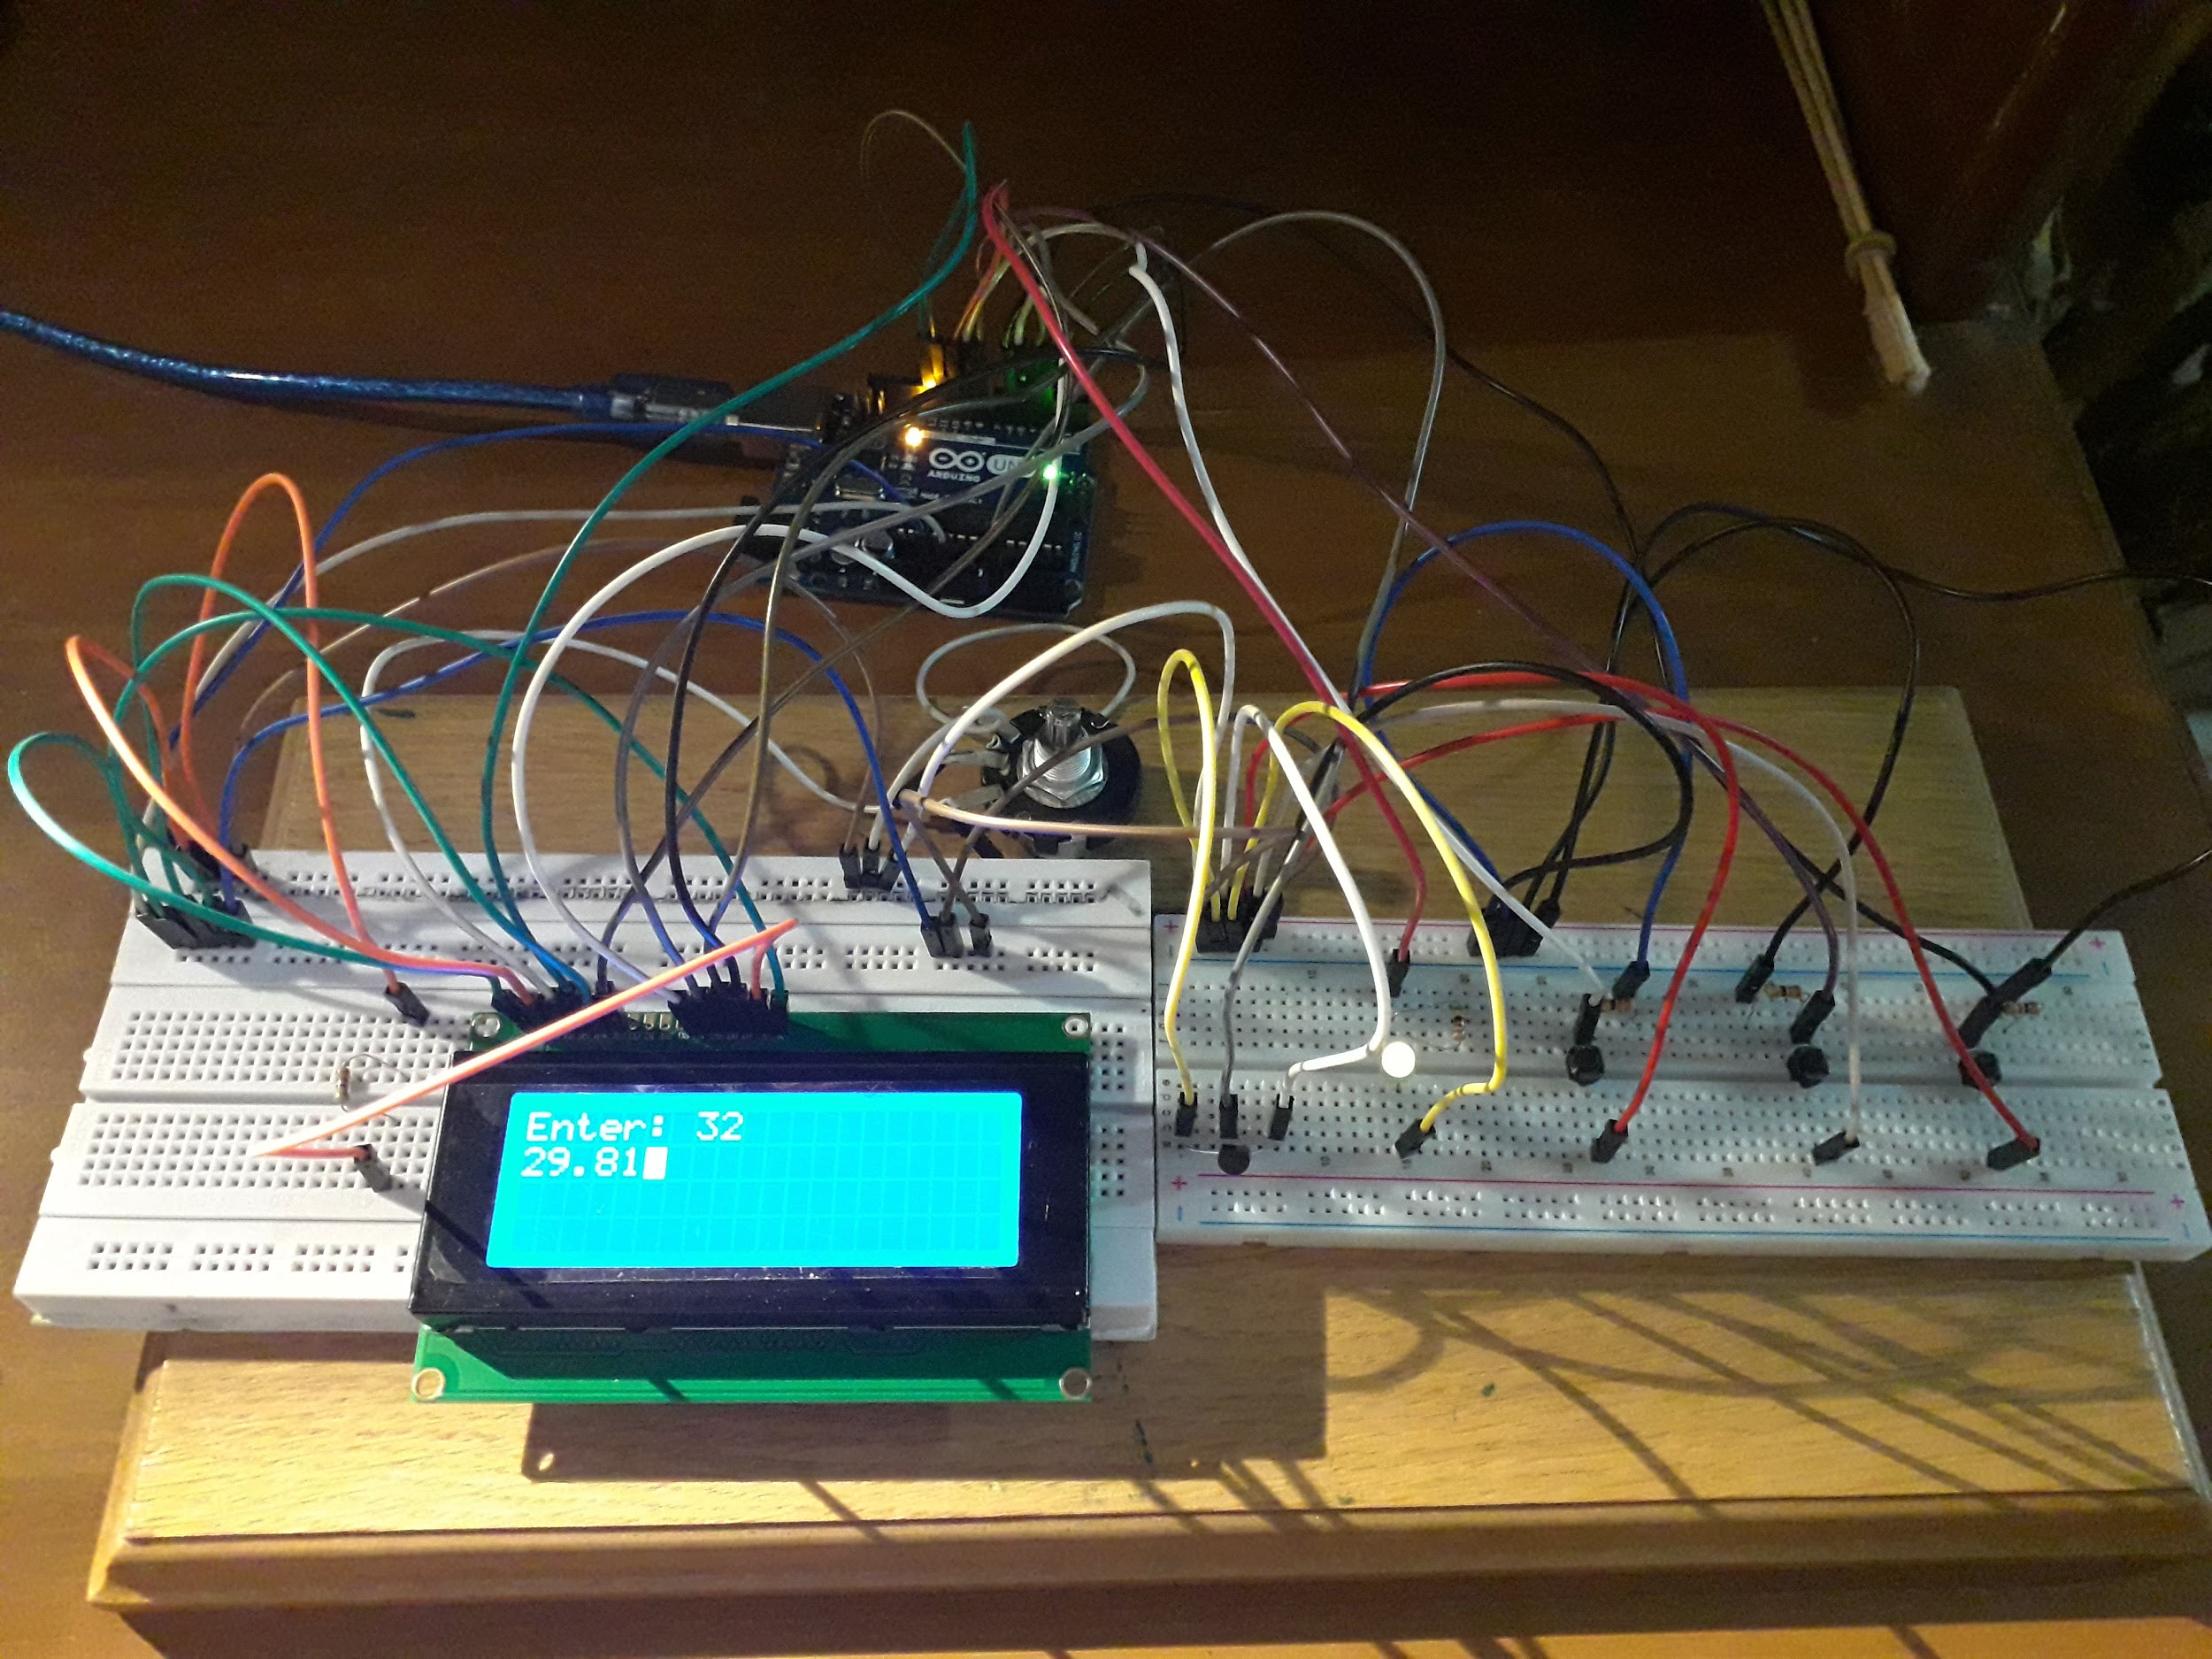

**Running Program Screenshots:**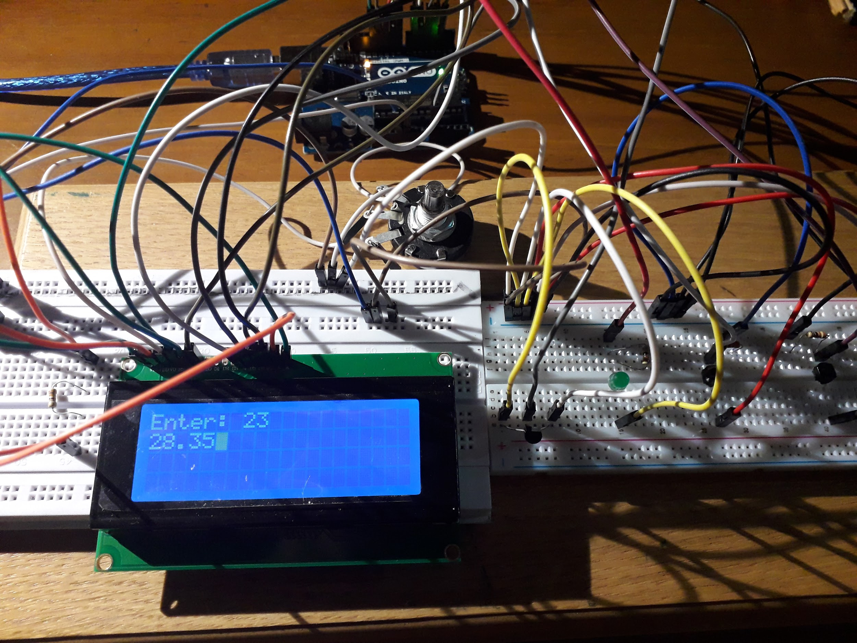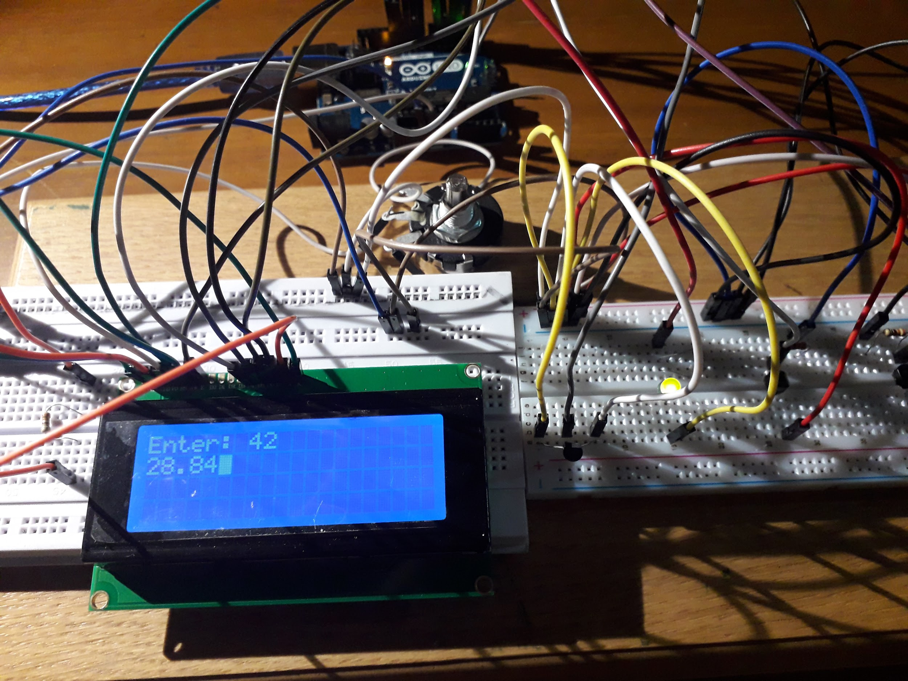



**References:**

* <https://www.arduino.cc/reference/en/language/functions/communication/serial/println/>
* <https://learn.adafruit.com/adafruit-arduino-lesson-2-leds/blinking-the-led>
* <https://www.instructables.com/id/Interfacing-20x4-LCD-with-Arduino/>
* <https://www.instructables.com/id/Arduino-Temperature-Sensor-Using-LM35/>
* <https://www.arduino.cc/reference/en/language/variables/data-types/string/functions/concat/>
* <https://www.arduino.cc/en/Tutorial.StringToIntExample>
* <https://www.tinkercad.com>